JAVA Assignment Question

Question1

Create an array with the values (1, 2, 3, 4, 5, 6, 7) and shuffle it.  
  
Code:

import java.util.Arrays;

import java.util.Random;

public class ArrayShuffle {

public static void main(String[] args) {

int[] array = {1, 2, 3, 4, 5, 6, 7};

shuffleArray(array);

System.out.println(Arrays.toString(array));

}

public static void shuffleArray(int[] array) {

int n = array.length;

Random random = new Random();

for (int i = n - 1; i > 0; i--) {

int j = random.nextInt(i + 1);

int temp = array[i];

array[i] = array[j];

array[j] = temp;

}

}

}

output :

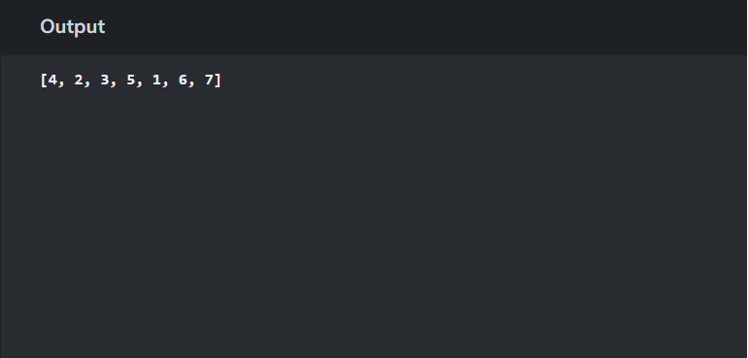

Question2

Enter a Roman Number as input and convert it to an integer. (Example: IX = 9)

Code:

import java.util.HashMap;

public class RomanToInteger {

public static void main(String[] args) {

String romanNumeral = "XII";

int result = romanToInt(romanNumeral);

System.out.println("Integer equivalent of " + romanNumeral + " is: " + result);

}

public static int romanToInt(String s) {

HashMap<Character, Integer> romanValues = new HashMap<>();

romanValues.put('I', 1);

romanValues.put('V', 5);

romanValues.put('X', 10);

romanValues.put('L', 50);

romanValues.put('C', 100);

romanValues.put('D', 500);

romanValues.put('M', 1000);

int result = 0;

for (int i = 0; i < s.length(); i++) {

char currentChar = s.charAt(i);

int currentValue = romanValues.get(currentChar);

if (i < s.length() - 1) {

char nextChar = s.charAt(i + 1);

int nextValue = romanValues.get(nextChar);

if (currentValue < nextValue) {

result -= currentValue;

} else {

result += currentValue;

}

} else {

result += currentValue;

}

}

return result;

}

}

Output:

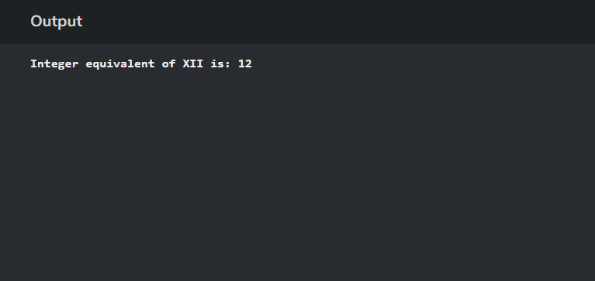

Question3

Check if the input is pangram or not. (A pangram is a sentence that contains all the alphabets from A to Z)

Code:

import java.util.HashSet;

public class PangramChecker {

public static void main(String[] args) {

String input = "hello duniya...ham pangram nai hai";

boolean isPangram = isPangram(input);

if (isPangram) {

System.out.println("The input is a pangram.");

} else {

System.out.println("The input is not a pangram.");

}}

public static boolean isPangram(String input) {

input = input.toLowerCase();

HashSet<Character> set = new HashSet<>();

for (int i = 0; i < input.length(); i++) {

char ch = input.charAt(i);

if (ch >= 'a' && ch <= 'z') {

set.add(ch);

} }

return set.size() == 26;

}}

Output:

